ANZAGG 3D Meeting Minutes

Wednesday 20 July 2022

# 1. Roll call with self-introductions

Meeting chaired by Leona Holloway, Monash University

14 people in attendance from Monash University, TSBVI, SPEVI, BLENNZ, See3D, NSW Department of Education, ACT Department of Education, NextSense, Victorian Department of Education, NNELS and Toyota Australia

# 2. Icebreaker – What have you been designing/printing in the last month?

Street crossing puzzle pieces designed by other group members <https://www.thingiverse.com/thing:5236166>.

Lots of butterfly kits, which come with a guide. Looking for people to send the models to, if you can give feedback.

[See3D](https://see3d.org/) models including anatomy and butterfly kits. They would like to do a similar collection for frogs, but could not find a model for the stage between tadpole and frog? Claire Garret has a frog life cycle kit available at <https://childsply.wixsite.com/catalogue/product-page/tadpoles>.

Created an Instructable on how to design your own [3D Bubble wands](https://www.instructables.com/Graphic-Art-3d-Printed-Bubble-Wands/). “I love this project because you can be creative, tactile, and quite advanced in your design if you would like. Almost importantly it prints fast!”

Testing slicers with JAWS. Slic3r was okay. Simplify 3D was the best. Hasn’t tested with other screen readers yet. Cura did not work with JAWS or Narrator. Hasn’t tested Octoprint yet as it is quite a process to get it set up. Another member has also been looking at Simplify3D. It has different problems with each screen reader.

# 3. Guest Speaker: Dennis Damsma, Toyota

Dennis Damsma, Studio Engineering & Milling Manager, Product Design, Product Planning & Development, at Toyota Australia in Melbourne.

## 3.1 3D printers and processes used at Toyota Design Studio

Toyota use 3D printing to test out early designs, to create custom fixtures, and to make customised tools.

Industrial FDM printers are expensive but very reliable. They mainly print with ABS for strength and soluble supports.

SLA printers are more expensive to run and require post-processing with ethanol bath and UV curing, support removal. The surface of the finished print is better quality.

Finishing: For clear/transparent prints they need to sand and polish/buff. For all external parts they prime and paint after the parts are printed.

## 3.2 Q&A

A member asked about the design process. This usually begins with sketching then clay models and refining before 3D scanning to create a 3D model. There is no substitute for the information that you can get from seeing a scale model.

Dennis asked whether 3D printed textures would be useful for touch readers?   
Leona has started developing 3D printed textures that are clearly distinguishable by touch, but she has only twice wanted to use them (on a school map and on learning beads). Often it is better to add texture with real materials like sandy paint or felt as these give more meaningful associations.   
Different textures might also be helpful for chemistry models, e.g. distinguish between carbon and oxygen, perhaps to use on maps, and also for realistic textures for animals, e.g. turtle shell.   
Another member has tried using 3D printed textures from Keyshot but they are too smooth. Adding the textures afterwards is better as it makes the model more realistic and meaningful. For example, you can add fake grass, textured paint, felt, etc. You can also print with squishy materials for things like organs.

The group discussed the possibility of moulding with clay and then scanning as a 3D model production pipeline for blind students. Those who have tried 3D scanning reported that a lot of post-processing is required. Nevertheless, using clay might help blind students to think about the shapes they are using before moving to modelling in OpenSCAD.

# 4. Guidelines

All completed guidelines are located at <https://printdisability.org/about-us/accessible-graphics/3d-printing/>.

## 4.1 3D printing on paper

A new section has been written on 3D printing on paper as an alternative to swell paper. Refer to the Appendix at the end of these minutes.

ACTION: Feedback requested from the group.

## 4.2 Visio learning pathway 3D-2D

The Visio “Learning pathway 3D-2D online’ is available and we can use it if we want. It is designed specifically for teaching students how 3D objects can be represented in 2D.

This resource is in Dutch. <https://www.eduvip.nl/onderwerp/themas/leerweg-3d-2d-online/>

Group members expressed interest in using the resource with their students.

# 5. Other Business

## 5.1 Tactile rulers

There is a 4 minute Dutch language YouTube tutorial on the tactile ruler by Visio, here: <https://www.eduvip.nl/liniaal/>.

## 5.2 3D printed calculus models

Joan Horvath and Rich Cameron are launching their Make: Calculus curriculum at the Pasadena 3D printing meetup on August 25. It is not designed specifically for touch readers but looks relevant. <https://www.meetup.com/pasadena-3d-printing-meetup/events/287003882/>

## 5.3 Idaho Makers for Equity Project

The Idaho Makers for Equity Project gives a list of 3D models that they would like to have printed for their blind and low vision students. See <https://stem.idaho.gov/apply/idaho-makers-for-equity/>

## 5.4 CosmoBally 3D printed model

Sonokids received a [Mable Community Grant](https://mable.com.au/communitygrants/) to produce 40 ready-made copies of CosmoBally. It will be announced next week, and people using the app can go into the draw to win. It comes with braille and QR code with description to know what it is and how to orient it.

# 6. Next Meeting

13 August 2022 Guest speaker – Ka Li on accessible Lego instructions.

# Appendix: 3D Printing on Paper (draft guidelines section)

If you don’t have access to tactile graphics equipment such as a swell paper machine, you may like to try 3D printing onto paper to create computer-generated tactile graphics.

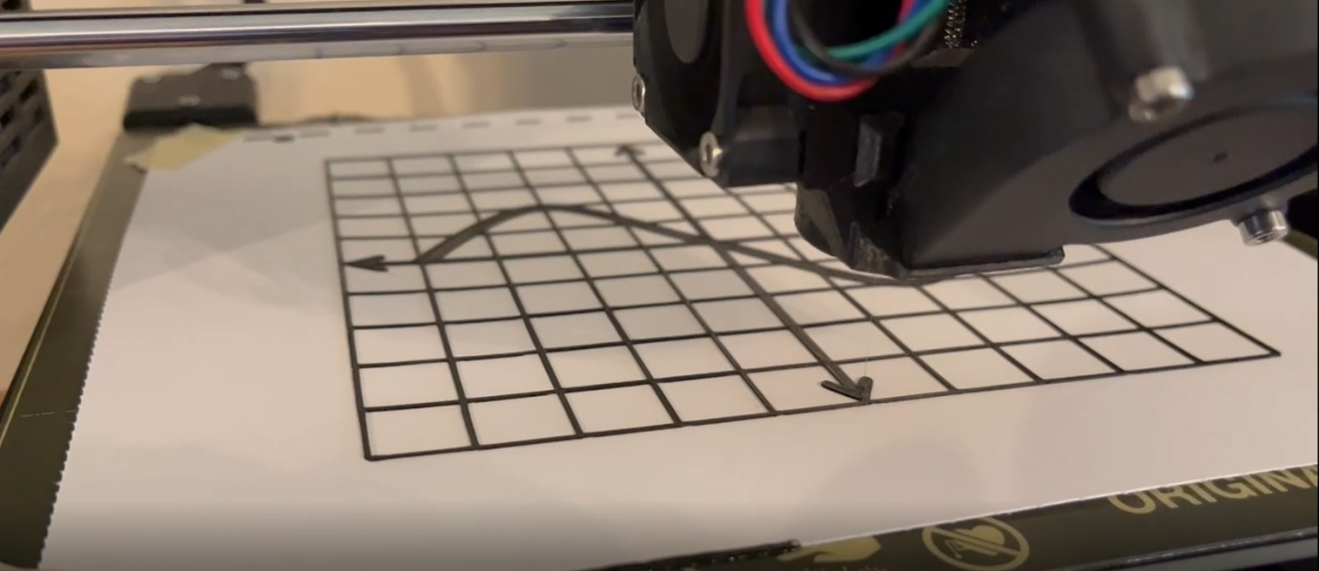

Prepare your image file.

* 1. Set the size of the image to match the size of your printing area.
  2. Design the image in a similar manner to a swell paper diagram:
  + Standard line thickness 2.25 point
  + Braille font size 24-26 point
  1. Save as PNG format. [Inkscape](https://inkscape.org/) is a free tool that will reliably convert images files to PNG.

1. Prepare your paper. Braille paper works well as its thickness means that it does not bend too much after printing.
   1. If you would like to add print labels for sighted/low vision users, do this now.
   2. Cut the paper to the size of your build plate.
2. Secure the paper to the build plate.
   1. Bulldog clips are a quick and easy method for securing the paper to the build plate and they do not cause damage. The more the better!
   2. If the paper is very thick, you may need to adjust the build plate height.

OPTION 1

1. Convert the 2D .png image to a 3D .stl.

OPTION 1: Import the .png file directly into [Cura](https://ultimaker.com/software/ultimaker-cura).

1. Specify that black areas should be raised
2. Choose a maximum height that is equal to your initial layer height. 0.25mm is recommended.
3. Set the base height at 0 so that the image will print directly onto the paper

OPTION 2: If your slicer does not accept image files, use the cowlicks automated tool

1. Go to <https://cowlicks.github.io/>
2. Upload your .png image
3. Check and download the resultant .stl file.
4. Slice
5. Ensure that the print size is the same as the original image size.
6. Check the maximum height of the initial layer in your slicer. 0.25mm is recommended.
7. Print
   1. For best results, use a flexible filament that will not peel off the page when it is bent. TPU filament works well. PET-G and nylon are other good options. However, note that flexible filaments work best on printers with a feed mechanism close to the print head. Ultimaker printers are not recommended for this type of filament.
   2. Use clear filament if you are 3D printing on top of an ink printed image, otherwise use a high contrast colour to assist users who have low vision.