ANZAGG 3D Meeting Minutes

Wednesday 16 February 2022

# 1. Roll call with self-introductions

Meeting chaired by Leona Holloway

14 attendees from Monash University, Victorian Department of Education, Hungry Fingers, Visio, SASSVI, ACT Department of Education, SPEVI, BLENNZ, NextSense, NSW Department of Education, ACT Department of Education

# 2. Feature Topic: 3D4VIP and 3D Printing Projects at Visio – Guest speakers Aukje Snijders, Ruben Brandsma and Evert Rasing

## 2.1 3D4VIP

The 3D4VIP project is a 3 year partnership between Visio (Netherlands), ASPAYM (Spain), Blista (Germany), Ilvesheim (Germany) and Sight Scotland. They are halfway through the project. It has five key areas:

1. Identify or develop an **accessible database for 3D models**. They have evaluated existing databases and are now deciding on what their “ultimate” database should look like. It will be called “Tactiles”. It will be multilingual. They have funding to support the website for the next 3-5 years. It is expected to go live in a year’s time.

* Nik commented that the database looks well though out, and asked if it will be open to everyone? Yes it will.

1. **Guidelines**. They have done a literature review on existing guidelines and are also testing models with BLV students.

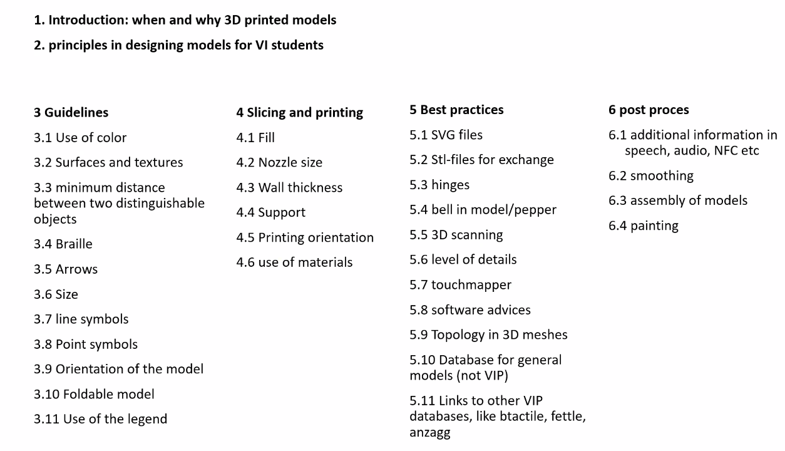

1. **Awareness program**. They are producing multi-lingual materials aimed at six key personas.
2. **Education materials for students with vision impairments**. Based on a teacher survey, they have identified a wish list of 25 models to be designed, prototyped, tested and shared as the first materials in the Tactiles database. The top 28 models are: floor plan standard; geographical maps; earth structure; playground / school yard; cells; spatial figures / mathematical shapes; atoms and molecules; traffic junctions; eye; every organ in the human body; biological development; tectonic plate shifts; volcanic eruptions; animals; bacteria/virus; historical maps; lung air sacks; microscopic things; pieces with textures; coat rack help; tactile games; musical notation and instruments; fraction circle; tactile protractor; heading angle gauge/wind rose; circulatory system; crossing schemes; blocks for flowcharts.

* Evert commented that they expected most of the models to be related to STEM, but there were a lot also related to the arts.
* A member commented some of the items are very location-specific – you don’t need coat racks in Queensland!
* A member asked which teachers were surveyed? As many as possible. At a member organisation they have worked with the curriculum developers to assist with identifying what models are needed.

1. **3D printing and designing with students with vision impairments.** They are looking at accessibility of the design software, slicing software and 3D printing hardware. In general, online slicers are most accessible – Ultimaker digital factory is recommended.

## 2.2 Implementation of 3D printing at Visio

* Visio have provided a standard set-up, with the same printers and filament on a trolley for five schools. This means that they can distribute models as a sliced files for “plug and play”.
* When they update their printers for the schools, they will choose Prusa.
* They send a “3D Print of the Week” to the schools for display to raise awareness of what sorts of materials can be 3D printed.
* they have a formalised request process for new designs. In 6 months they have received 30 requests.
* Tactile ruler
  + The RNIB tactile ruler is no longer produced
  + New ruler tested with 20 people and went through many iterations
  + New ruler also has a moveable line stop to draw lines of a set distance, and holes for use as a compass or to pin the ruler down. The base is rough so that it is more stable.
  + Final product was injection moulded then printed on top. A minimum of 5,000 pieces needed to be ordered for injection moulding. For injection moulding, every vertical angle must be at least 10° offset so that it will release from the mould.
  + Production cost was around 5 Euro per ruler.
* Braille kit
  + 27 kits with interlocking tiles with braille and print letters, numbers, a braille cell and braille dot pins, and a board.
  + The braille cells were outsourced for FDM printing, the board was laser cut and the braille tiles were SLS printed

# 3. Other Business

## 3.1 Architecture

A member is seeking advice on materials for a high school student interested in architecture

Mini World is a good source of architectural models: <https://www.myminifactory.com/users/MiniWorld>

## 3.2 Liability

A member is seeking advice regarding liability around developing, printing and sharing 3D models. They are concerned about the legalities in case of injuries, choking, etc.

Another member has consulted lawyers regarding this issue. They advised that for anything we print and distribute ourselves, we should include a warning label.

# 4. Next Meeting

17 March 2022, 11.30am AEDT