3D printing for tactile literacy – Survey and results
This survey is designed for educators working with vision impaired touch readers from Foundation level to Year 2.
Instructions: Please indicate your selected responses with an X in the next table cell. If you select “other”, please explain with text below the table. Your saved completed document should be emailed to leona.holloway@monash.edu or mailed to
Leona Holloway
Level 6, Building H, Caulfield Campus
Monash University
900 Dandenong road
Caulfield East VIC 3145
An online version of this survey is also available at https://tinyrurl.com/access3Dsurvey.

Agreement
I have read the explanatory statement below and I agree to take part in Monash University research project 18075 investigating 3D printing to improve access to graphics by people with vision impairments.
Yes
No

About you

What is your work role?
Specialist vision teacher (visiting/itinerant teacher)
Classroom teacher
Classroom aide
Other:

Location
Australian Capital Territory
New South Wales
Northern Territory
Queensland
South Australia
Tasmania
Victoria
Western Australia
New Zealand
Other:

How many vision impaired students do you currently work with?
Number:

How many of these students are in the first three years of schooling?
Number:

Do you have access to a 3D printer?
Yes
No
Unsure

Accessible materials for the classroom
For each of the following topic areas, please indicate what materials you are already using (“Already using”) and what other materials may be of value to your student (“Wanted”). “Not needed” indicates that your student does not need to study this topic area.

Introducing braille cells
Item | Already using | Wanted
Not needed
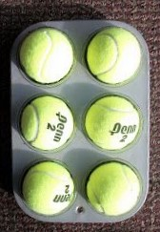
handmade representation of braille cell,
e.g. muffin tray with balls

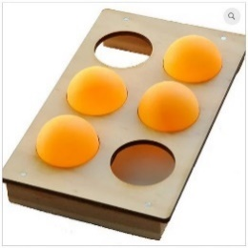
purchased representation of braille cell

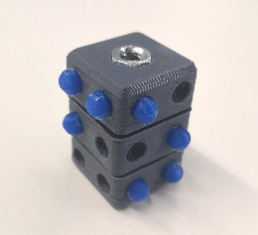
3D printed braille fidget cube

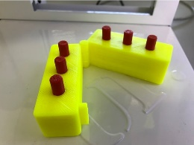
3D printed braille swing cell
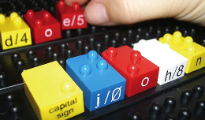
Tack-Tiles
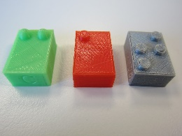
3D printed braille bricks
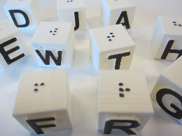
3D printed braille building blocks
Other:

Story books
Item | Already using | Wanted
Not needed
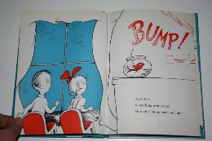
Standard print books read aloud
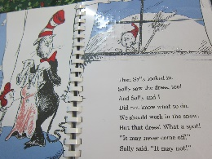
Standard print books with braille added
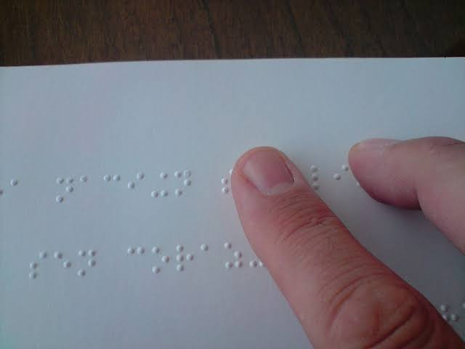
Braille books without illustrations
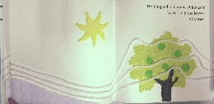
Tactile story books with braille and tactile illustrations
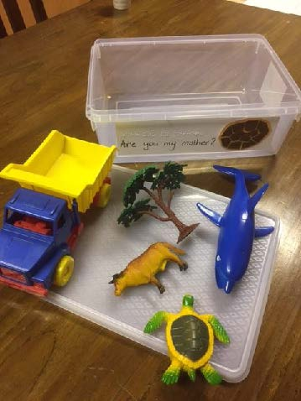
Tactile story boxes containing items relating to the story
Other:

MAB blocks
Item | Already using | Wanted
Not needed
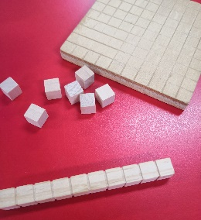
Standard MAB blocks
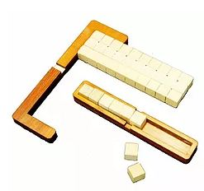
Purchased frames for counting with standard MAB blocks

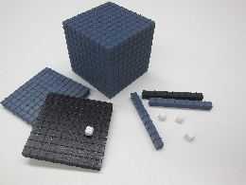
3D printed accessible blocks with raised lines
Other:

5/10s frame
Item | Already using | Wanted
Not needed
Tactile graphic
Handmade tactile grid
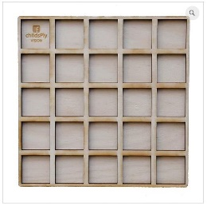
Purchased tactile grid
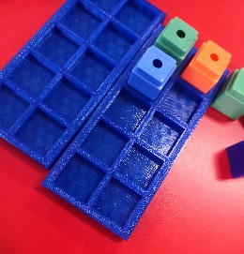
3D printed frame

Other:

Objects for counting or building patterns
Item | Already using | Wanted
Not needed
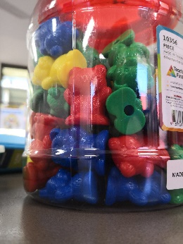
Standard classroom objects, e.g. counters, pop sticks, plastic bears, beads, lego bricks, sticky back foam shapes, etc.
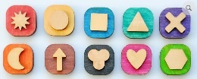
Additional objects with clear tactile differences, e.g. mixed pasta, bottle tops, tactile shape counters, etc.
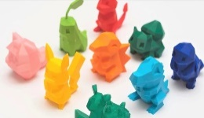
3D printed objects to suit the student's interests
Other:

Dice
Item | Already using | Wanted
Not needed
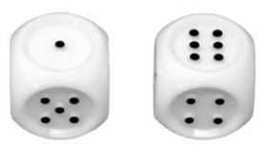
Commercially available tactile dice

3D printed tactile dice

Other:

Dominos
Item | Already using | Wanted
Not needed
Standard domino with braille or tactile dots added
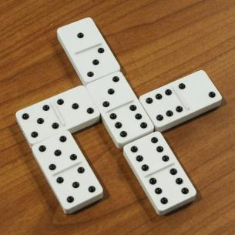
Purchased tactile domino set

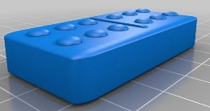
3D printed tactile domino set

Other:

Number lines
Item | Already using | Wanted
Not needed
Brailled number lines
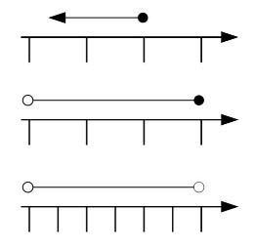
Tactile graphics
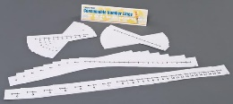
Purchased accessible number lines

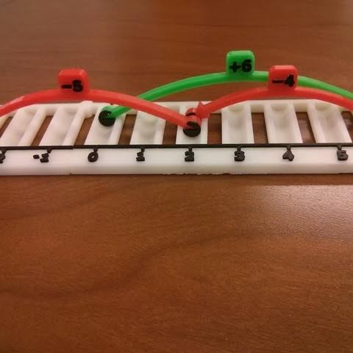
3D printed number line
Other:

Measurement
Item | Already using | Wanted
Not needed
Standard tools with tactile markers added | 2
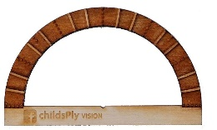  Purchased accessible tools | 1
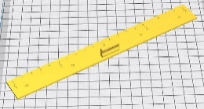  3D printed ruler with tactile markers |  | 2
Other:

Fractions
Item | Already using | Wanted
Not needed
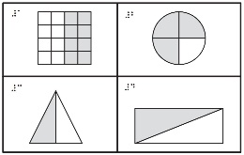
Tactile graphics
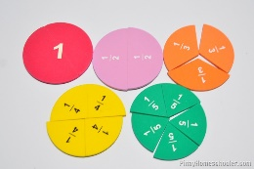
Standard materials, e.g. wooden cake in slices, fraction pies, etc.
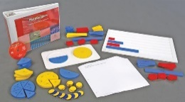
Purchased accessible fraction tools

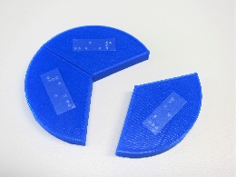
3D printed accessible fraction tools
Other:

Flat shapes
Item | Already using | Wanted
Not needed
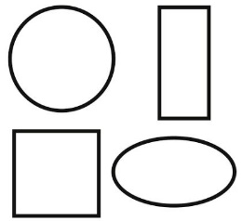
Tactile graphics
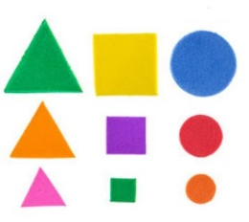
Handmade tactile flat shapes,
e.g. cut from cardboard or foam
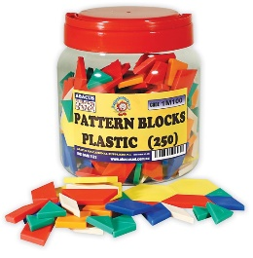
Purchased flat shapes
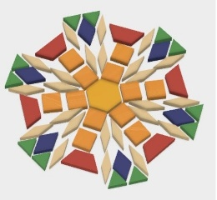
3D printed flat shapes
Other:

3D shapes
Item | Already using | Wanted
Not needed
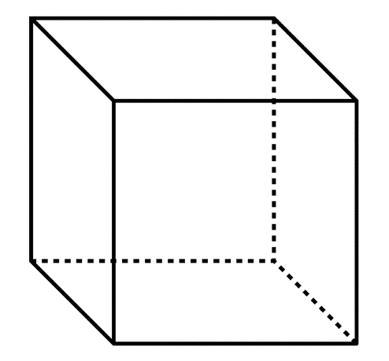
Tactile graphic with projections
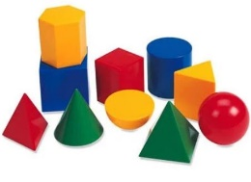
Purchased 3D shapes
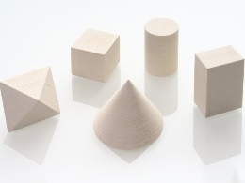
3D printed 3D shapes
Other:

Nets
Item | Already using | Wanted
Not needed
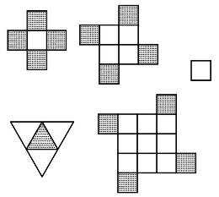
Tactile graphics
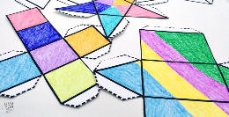
Handmade nets
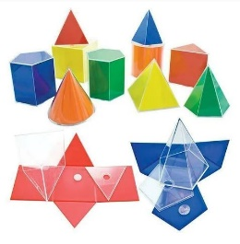
Purchased nets
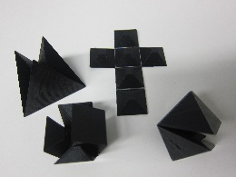
3D printed nets

Other:

Clock time
Item | Already using | Wanted
Not needed
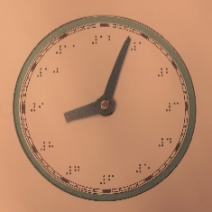
Tactile graphics

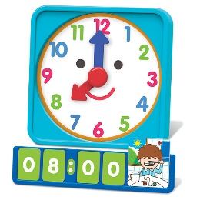
standard clock or learning clock with tactile labels added
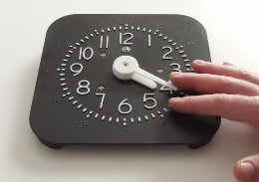
accessible clock or learning clock

Other:

Data grids
Item | Already using | Wanted
Not needed
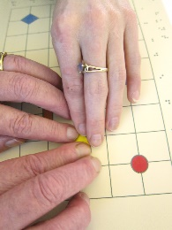
Tactile graphics

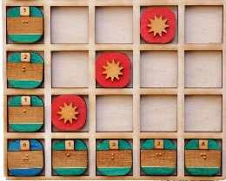
Purchased accessible data grid
3D printed data grid

Other:

Maps
Item | Already using | Wanted
Not needed
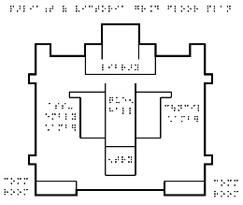
Tactile graphics
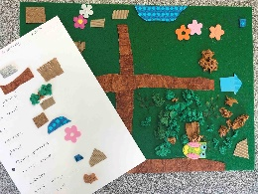
Handmade tactile maps,
e.g. using spur wheel, wikki stix, collage

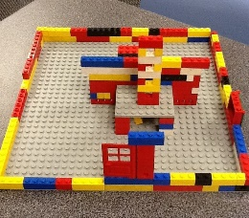
Handmade 3D maps,
e.g. using blocks, lego or classroom props
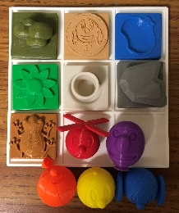
Ballyland Code app with 3D printed props
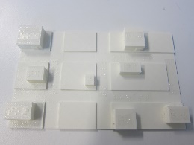
3D printed maps
Other:

Animals
Item | Already using | Wanted
Not needed
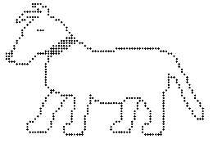
Tactile graphics
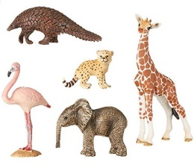
Purchased toy animals
Other:

Additional materials
Used:
Wanted:

Priorities when choosing classroom materials
How important are each of the following factors when choosing classroom materials for vision impaired students?
1 = not at all important
5 = extremely important
Consideration | 1 | 2 | 3 | 4 | 5
Cost
Convenience – the materials are already in the classroom for use by sighted students
Tactile properties – the materials are easily distinguished by touch and appealing to the student
Storage – the materials do not take up too much extra storage space
Readiness – the materials can be sourced quickly
Staff time – the materials do not need to be prepared by school staff
Environmentally friendly – the materials can be recycled or re-used
Inclusion – the materials can also be used by sighted peers

Your contact details
Please provide your email address if you are located in Australia or New Zealand and you are interested in receiving and testing some of the 3D printed materials that you indicated would be of value to your student(s).
Email:

-----------------------------

Explanatory Statement
You are invited to take part in this study. Please read this Explanatory Statement in full before deciding whether to take part in this research. If you would like further information regarding any aspect of this research, you are encouraged to contact the project investigators using the details listed below.

WHAT DOES THE RESEARCH INVOLVE?
This project aims to transform the provision of accessible graphics within Australia by exploring 3D printing as a new method for conveying graphics through touch.
Monash University is partnering with the Victorian Department of Education & Training, RIDBC, SPEVI and others to investigate the use of 3D printed models for teaching tactile literacy and STEM to children who are blind or have low vision. You are invited to complete this survey to help identify models that may be helpful in the classroom.

WHY WERE YOU SELECTED FOR THIS STUDY?
Group 1: You were selected for this study as you are a specialist teacher or aide working with students with vision impairment through one of the project partner organisations: The Department of Education and Training Victoria, Royal Institute for Deaf and Blind Children, or a member of South Pacific Educators in Vision Impairment.

CONSENT AND WITHDRAWAL
Participation in this study is entirely voluntary.
Participation in this study is not a workplace requirement. You may use the 3D printed materials being offered without participating in the study. Your inclusion or exclusion in the study will be known only by the researchers; not by your workplace managers or colleagues.

SOURCE OF FUNDING
This research is funded by the Australian Research Council (ARC) Linkage Project LP170100026, with support from the Department of Education and Training Victoria, Round Table on Information Access for People with Print Disabilities, Inc., South Pacific Educators in Vision Impairment, Royal Institute for Deaf and Blind Children, Guide Dogs Victoria and the Royal Society for the Blind.

POSSIBLE BENEFITS
The project aims to benefit the low vision community by supporting the use of 3D printed models for improved access to graphics.

POTENTIAL RISKS
This research involves minimal risks.

CONFIDENTIALITY
Your participation in this study will not be made known to others and your details will remain confidential.
Results will be published in aggregated form so that individual participants cannot be identified.

STORAGE OF DATA
Data relating to the project will be retained for a minimum of five years, in accordance with research requirements. The raw data will be stored in a secure location able to be accessed only by the research team.
After it is no longer required, all data will be destroyed in a secure manner.

RESULTS
Results of the study and overall project will be published through academic and professional journals and conferences, and be used to form the basis of guidelines to be published by Round Table.
Notification of publications will be made available at accessiblegraphics.org and results will be made available on request.

COMPLAINTS
Should you have any concerns or complaints about the conduct of the project, you are welcome to contact the Executive Officer, Monash University Human Research Ethics (MUHREC):
Executive Officer
Monash University Human Research Ethics Committee (MUHREC)
Room 111, Building 3e
Research Office
Monash University VIC 3800
Tel: +61 3 9905 2052
Email: muhrec@monash.edu
Fax: +61 3 9905 3831
Research Assistant: Leona Holloway
Department of Information Technology
Monash University
Phone: (03) 990 32401
email: leona.holloway@monash.edu
Chief Investigator: Prof Kim Marriott
Department of Information Technology
Monash University
Phone: (03) 990 55525
Email: kim.marriott@monash.edu
Chief Investigator: Dr Matthew Butler
Department of Information Technology
Monash University
Phone: (03) 990 31911
Email: matthew.butler@monash.edu
Partner Investigator: Sonali Marathe
Royal Institute for Deaf and Blind Children (RIDBC)
Phone: (02) 9872 0234
Email: sonali.marathe@ridbc.org.au
Partner Investigator: Debra Lewis
Statewide Vision Resource Centre
Phone: (03) 9841 0242
Email: lewis.debra.d@edumail.vic.gov.au

